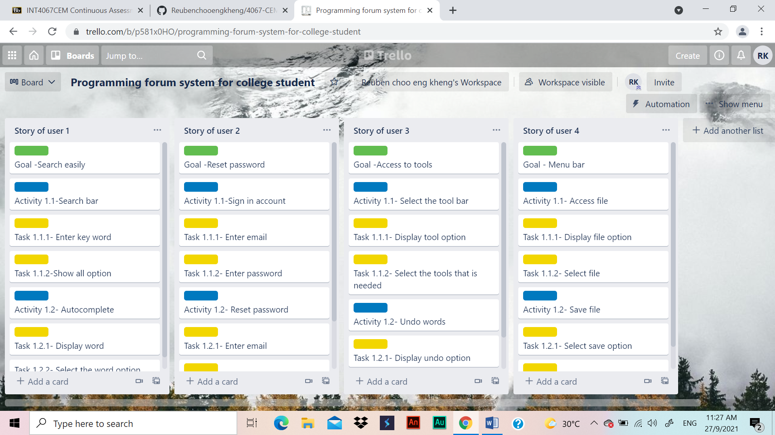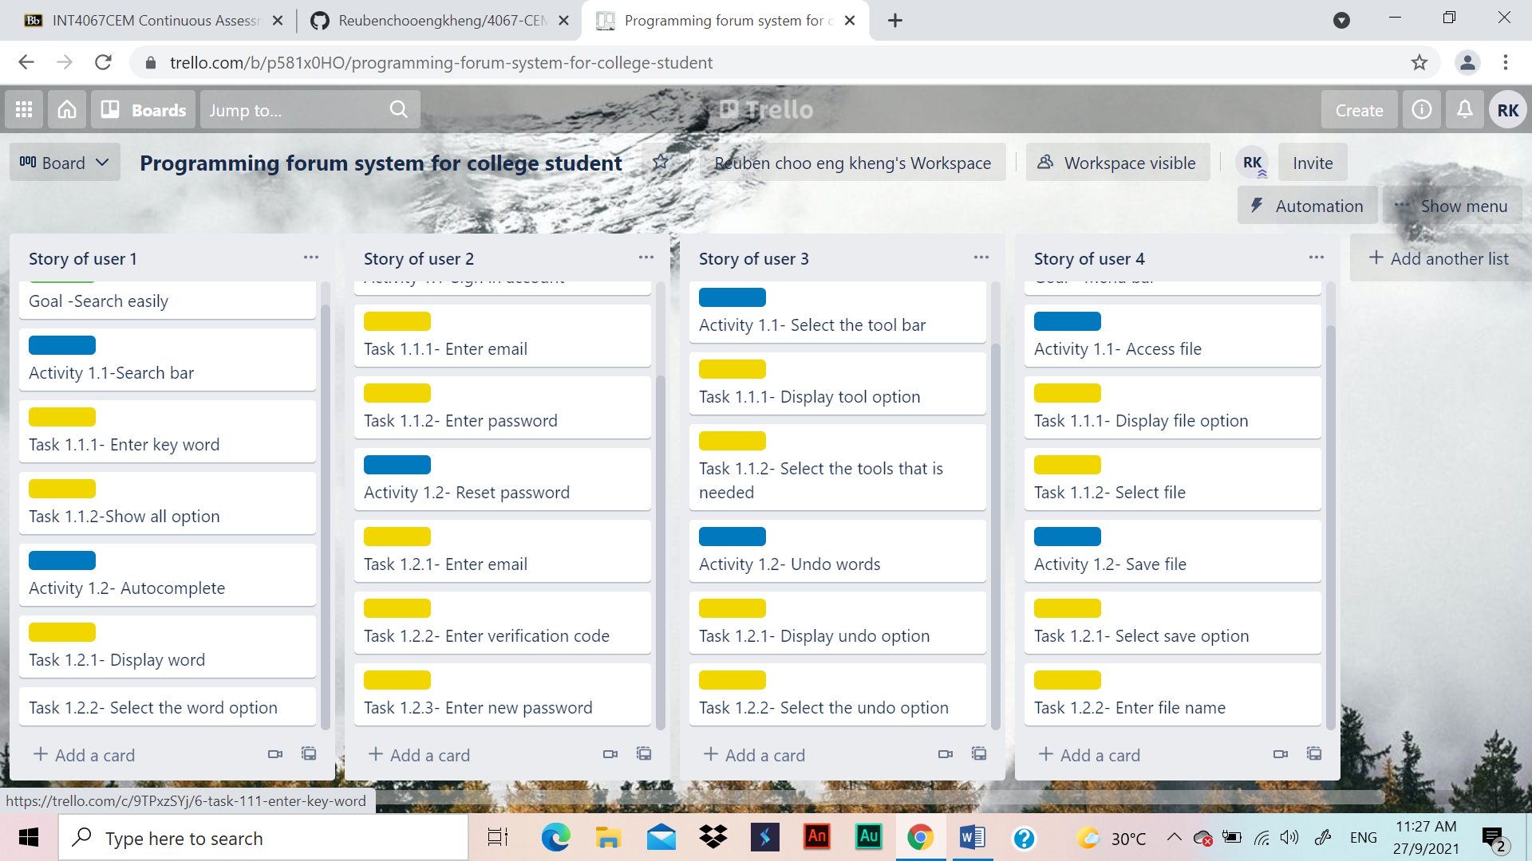

User story

User 1- I want to search up the things that I need easily to finish my project faster

User 2- Reset my password to make sure my account stay safe

User 3-I want to use the tools to assist me in my task

User 4- menu bar for easier access to file option